
GUÍA DE TRABAJO NO PRESENCIAL No. 7
NOMBRE DEL ESTUDIANTE: |  |  | CURSO:
GRADO: Séptimo | CURSO(S): 7(1,2,3,4,5) |  | TIEMPO: 3 SEMANAS (12 HORAS)
ÁREA: Humanidades | ASIGNATURA(S): Inglés y taller de Inglés
DOCENTE:  María Luisa Mendoza | No. DE CELULAR:  3114719264 | CORREO ELECTRÓNICO:  maria.mendoza@itgonzalosuarez.edu.co
Apreciado estudiante, la presente guía tiene por objeto plantear una serie de actividades que usted debe desarrollar de manera autónoma y responsable en su casa haciendo uso de los recursos de los cuales disponga (internet, bibliografía, cuaderno, entre otros). Se le recuerda que las actividades no exigen su desplazamiento fuera de su hogar y que los medios a través de los cuales puede hacer entrega del desarrollo de la guía son: en físico, al correo electrónico del docente o por medio de WhatsApp.
DESEMPEÑO: - I can identify typical characteristics of different countries.
- I can compare typical characteristics of countries.
- I can talk about things that are happening now.
TEMA: Weather, Seasons, Comparatives, Superlatives, Present continuous.
ACTIVIDADES DE EXPLORACIÓN
- Look at the photos, find the location of the places, and answer the questions with true or false. 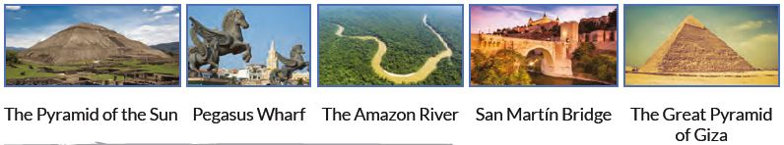
 | True | False
The Great Pyramid of Giza is located in Mexico.
The Amazon river is located In Chile.
The San Martin Bridge is located in Toledo, Spain.
Pegasus wharf is located in Cartagena de Indias, Colombia.
The Pyramid of the Sun is located in Egypt.
1) Read the text from a professional travel blogger talking on his live video. Complete what he says correctly using the words from the box. (1–9
Hey, what’s up? Welcome to my live vlog feed From Colombia to the World! Today, I’m visiting the 1__________city of Cairo in the 2__________country of Egypt. Cairo is the capital of Egypt and is located near the 3__________ Pyramids of Giza. I’m having a 4 __________ time, but I’m also very hot! Egypt is located in the north of Africa, so the weather is usually 5__________and sunny: the highest temperatures are in summer. Most people speak Arabic, which is the 6__________language, but a lot of people also speak French. The 7__________ population of Egypt is about 92 million, of which an
8 __________ 9.7 million live in Cairo. Cairo is bigger than Bogotá, where the population is about 7.9 million. Actually, Cairo is the biggest city in Egypt. Although Egypt is a 9__________country, it is smaller than Colombia. The River Nile flows through Egypt and is about 6,853 kilometres long and is the second longest river in the world. The Nile isn’t the longest river in the world, because the Amazon is 139 kilometres longer than the Nile!
- Famous
- Astonishing
- Fascinating
- Warm
- Total
- Big
- Wonderful
- Oficial
- incredible
Reading # 1

- Answer the next questions about previous reading. Use the words of the reading. Look at the example:
- What are the temperatures like in Egypt during the summer? _ The highest__________________________________________.
- What language do the majority of people speak? ________________________________________________________________.
- Is Cairo a big city? _________________________________________________________________________________________.
- Is Egypt a big country? ______________________________________________________________________________________.
e) Is the River Nile long? ________________________________________________________________________________________.
f) What is the name of the most important city in Egypt? _____________________________________________________________.
g) When are the temperatures highest in Egypt? ____________________________________________________________________.
h) What language do the majority of people speak in Egypt? __________________________________________________________.
i) What other language do some people speak in Egypt? ______________________________________________________________.

ACTIVIDADES DE ESTRUCTURACIÓN Y PRÁCTICA

The adjective: An adjective is a word that describes an animal, person, thing, or thought. Adjectives include words that describe what something looks like and what it feels like to touch, taste, or smell. Adjectives can be colors or words that describe temperatures and sizes.
An adjective modifies a noun; that is, it provides more detail about a noun. This can be anything from color to size to temperature to personality. Adjectives usually occur just before the nouns they modify.
We can use adjectives to describe people and things. Find in the word search the adjectives into the box
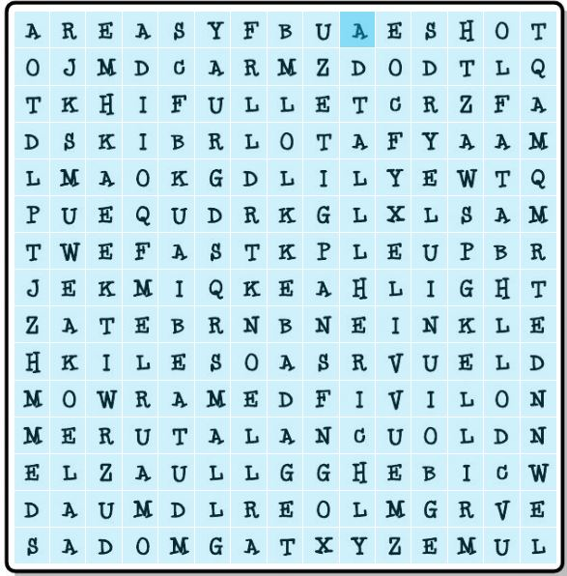
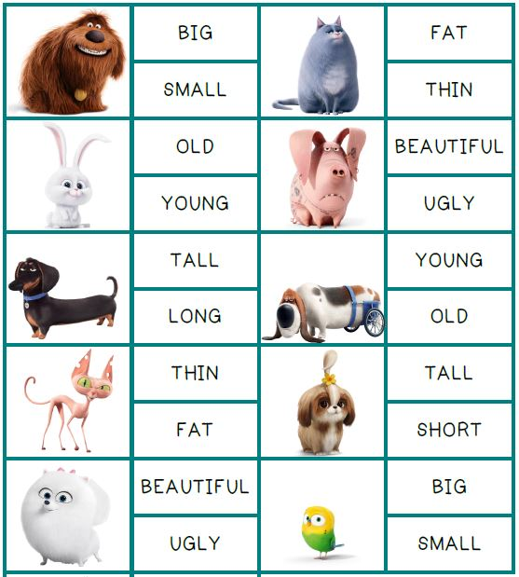
Look at the pictures and mark an x in the right adjective.
- Wet - slow - thin - empty - heavy – good - Difficult - poor - strong - young – happy - cold – short – big.
The adjective:
Un adjetivo es una palabra que acompaña y modifica al nombre. Puede ampliar, complementar o cuantificar su tamaño. Son palabras que nombran o indican cualidades, rasgos y propiedades de los nombres o sustantivos a los que acompañan.
The tall man the red ball a cold winter a pretty woman a blue car a big animal
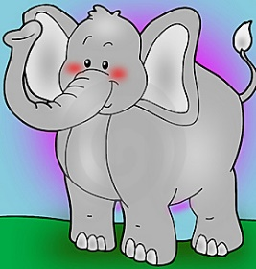
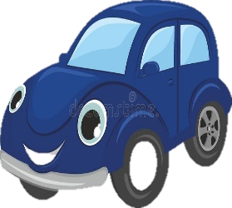

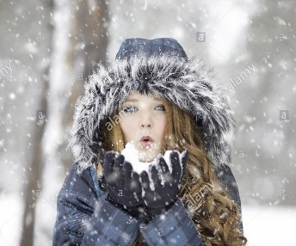

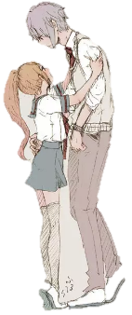

We use the comparative and superlative forms of adjectives and adverbs to compare things, people, actions and states in our writing.
The comparative form is used to compare one person, thing, action or state to another:  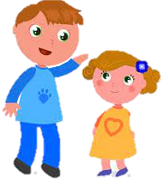  - My sister is smaller than me.  - That bag of rice is heavier than the other.  - The library is quieter than the other.  - Roses are prettier than daisies. | The superlative form is used to compare one thing to all the others in the same category; in other words, when the comparison is taken to the highest degree possible, for example:  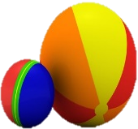  - This ball is the smallest.  - My backpack is the heaviest.  - My jacket is the prettiest.
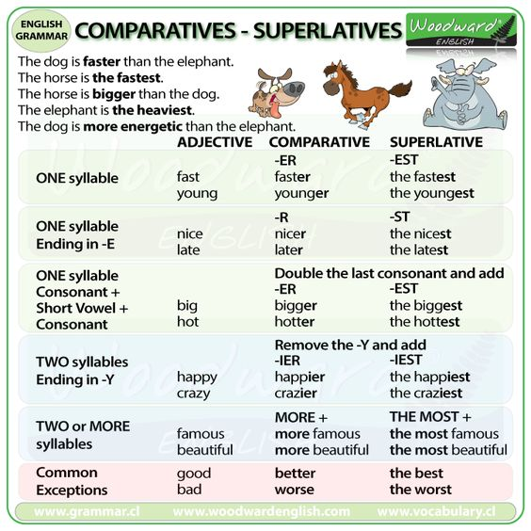
Analyze and learn the following table, pay attention to the rules for using comparatives and superlatives.
The three main exceptions are:
Adjetivo base | Forma comparativa | Forma superlativa
good (bueno) | Tim is better than Steve at tennis (Tim es mejor que Steve en tenis). | Serena Williams is one of the best tennis players in the world (Serena Williams es una de las mejores jugadoras de tenis del mundo).
bad (malo) | This winter is worse than last year’s winter (Este invierno es peor que el del año pasado). | At school, I was the worst in the class at Geography (En el colegio yo era el peor de la clase de geografía).
far* (lejos) | Mars is further than the Moon from planet Earth (Marte está más lejos que la Luna del planeta Tierra). | In our solar system, Neptune is the furthest planet from the sun (En nuestro sistema solar, Neptuno es el planeta más lejano respecto al sol).

You are going to compare characteristics of countries and cities through the use of comparative and superlative adjectives. Pay attention to the order of the sentence. Look the examples in blue:
Tunja is more colder than Cali | Medellin is the second largest city in Colombia
Santa Marta is the older city in Colombia. | Tunja is smaller than Bogotá
Put the words in order to make sentences (1–6). Look at the reading # 1
1. smaller / is / Bogotá / Cairo / than ________Bogota is samaller than bogota_______________________________________.
2. is / the / largest city / Cairo / in Egypt ______________________________________________________________________.
3. winter / in Egypt / is / Summer / than / hotter _______________________________________________________________.
4. in Egypt / is / spoken language / Arabic / the most ____________________________________________________________.
5. covers / Egypt / than / Colombia / a larger area _______________________________________________________________.
6. the longest / in the world / river / The Amazon / is ____________________________________________________________.
7. Is Cairo smaller than Bogotá? _____________________________________________________________________________.
8. Is Colombia bigger than Egypt? ____________________________________________________________________________.
9. Is the Nile the longest river in the world? ____________________________________________________________________.
10. How long is the Amazon? ________________________________________________________________________________.
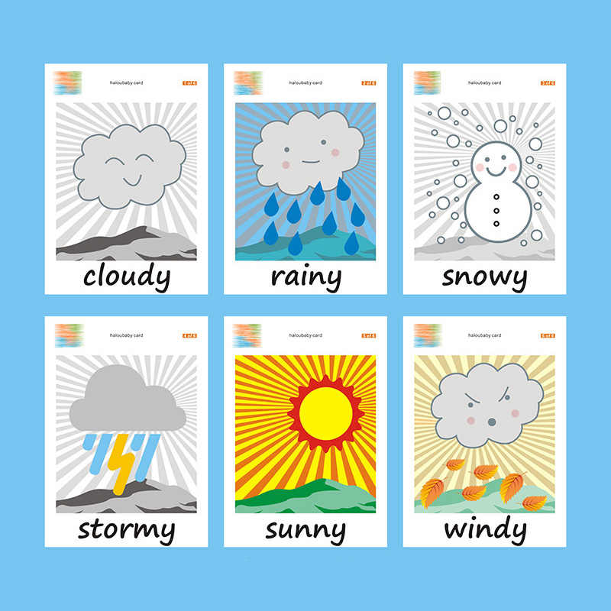
Weather
- Weather is sunshine, rain, snow, wind, and storms. It's what is going on outside right now.
- The weather is different at different places around the planet.
SEASONS
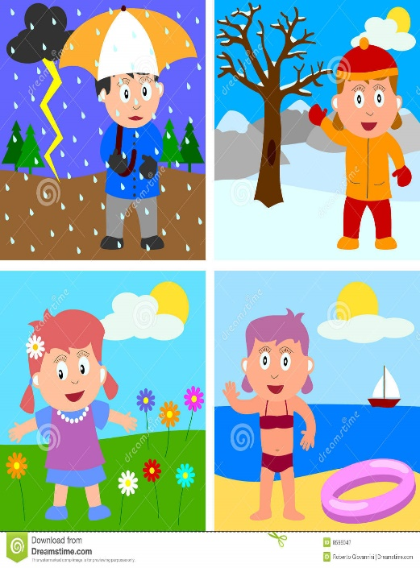
The seasons are four different times during the year with different types of weather. They are spring, summer, fall, and winter, and are caused by the earth's orbit around the sun, its rotation on its axis, and its tilt.
- In autumn the amount of time it is light for becomes less, the leaves start to change colour and fall off the trees. Autumn is called Fall in the United States of America.
It´s autumn and Anna is Carrying a basket to collect the autumn leaves.
- In winter we have colder weather, sometimes snow and frost, the trees have no leaves and the amount of time it is light during the day is at its shortest.
It´s winter and Anna is wearing a warm coat.
- In spring the weather usually turns warmer, trees begin to grow their leaves, plants start to flower and young animals such as chicks and lambs are born.
It´s spring and Anna is walking to the beach to swim.
- In summer the weather is usually warm, trees have full green leaves and the amount of time it is light for during the day is longer.
It´s spring and Anna is playing with the flowers.
Present continuous
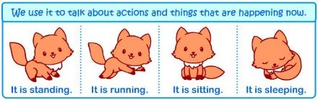
We use the present continuous to describe what is happening at the moment. We form the present continuous with be + -ing.
Affirmative: subject + be + -ing
Roberto is sleeping at the moment.
Negative: subject + be not + -ing
They aren’t missing their dog.
Questions: be + subject + -ing
Am I sleeping?
Short Answers: Yes, I am. - No, I’m not.
–Yes, he/she/it is. - No, he/she/ it isn’t.
- Yes, you/we/they are. /No, you/we/ they aren’t.

To make the present continuous we add – ing to the base form of the verb.
There are some verbs that can´t usually be continuous. Here are some common examples:
Be ate know
Like love need
Think want

For most verbs we just add ing. | Read = reading  Sing = singing
When the verbs ends in –e, then we drop that e and add ing. | Dance = dancing  Write = writing
When the verbs ends in a consonant with a vowel before it, we double the consonant and add ing. | Run = running  Sit = sitting

ACTIVIDADES DE TRANSFERENCIA Y VALORACIÓN

  - Read the e-mail about an amazing trip and answer the questions using the present continuous (1–7).
Hey Mum and Dad,
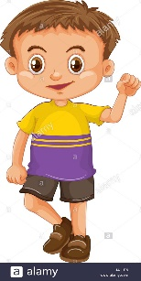
Today is the second day of our amazing trip and we’re having a wonderful time! The sun is shining and it’s really warm, so I’m wearing my T-shirt and shorts. I don’t need that big coat that Mum put in my suitcase for me . We’re staying in a small hotel near the city centre and the owners are very friendly. I’m sharing a room with Roberto. We’ve got bunk beds, so Roberto sleeps on the top bunk and I’m on the bottom! It’s only 8 a.m. now and Roberto is still sleeping, so I’m trying to be very quiet because I don’t want to wake him up! I’m really enjoying this trip, but I’m missing everyone at home, especially Bob the Dog! Lots of love, Carlos.

1. Is Carlos having a good time on his school trip?__________________________________________.
2. What is the weather like?___________________________________________________________.
3. What clothes is Carlos wearing?______________________________________________________.
4. Where are they staying?____________________________________________________________.
5. Who is Carlos sharing a room with?___________________________________________________.
6. What is Roberto doing while Carlos is writing to his Mum and Dad?__________________________.
7. Who is Carlos missing the most?_____________________________________________________.
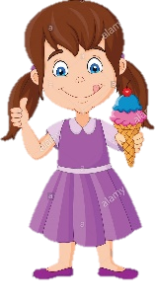
  - Convert the next sentences into the present continuous: look at the example.
Example: Maria: buy an ice cream = Maria is buying an ice cream.
1. Michael: sleep on the train__________________________________________________________.
2. The tourists: visit a city _____________________________________________________________.
3. Luisa: watch a video on the bus______________________________________________________.
4. My grandparents: walk on the beach__________________________________________________.
5. Manuel: buy a ticket_______________________________________________________________.

  - Read the next text about a trip in Brazil. Fill the blanks with the words in the box.
- dishes
- photos
- lessons
- lunch
- beach
- tourists
- friend
- accent
I’m in Rio de Janeiro, Brazil, and I’m having 1________________in a small café in the main square. The food here is delicious and a Portuguese 2___________is teaching me how to make some typical Portuguese 3___________! I’m also learning to surf and I have 4________________every day; I wanted to have a class today, but it’s raining, so I can’t. The people are really nice here and I’m learning lots of Portuguese, which is great, but my 5__________ isn’t very good! There are lots of interesting things to see and I’m taking hundreds of 6 _______________to post on my blog. Check out the ones I took of the statue of Christ The Redeemer at the top of Corcovado Mountain.They’re not bad, but there are always lots of other 7________________taking photos of the statue too and it’s hard to take a good photo. Anyway, I have to go now because it’s finally stopped raining and the sun is shining, so I’m off to the 8____________ for my surf lesson!

  - Put the words in order to make questions about the previous reading,. Finally answer the questions. See the example (1–6)

1. is / Where / he / lunch / having / ?__ where is he having lunch?______________________________________________.
2. Portuguese dishes / Who / to cook / teaching / is / him /? _____________________________________________________
______________________________________________________________________________________________________.
3. is / sport / he / to do / What / learning /?___________________________________________________________________.
4. language / What / learning / he / is / ?__________________________________________________.
5. of the statue of Christ / to take good photos / Why / is it difficult / ?___________________________
_________________________________________________________________________________.
6. at the end of the blog post / Where / he / is / going?_______________________________________.

1. ________He is having lunch in a small café__________________________________________.
2.________________________________________________________________________________.
3.________________________________________________________________________________.
4.________________________________________________________________________________.
5.________________________________________________________________________________.
6.________________________________________________________________________________.

  - Choose the best option to complete the sentences.
Medellin is the second ____________ city in Colombia.  a. largest than b. most large d. Largest c. larger | Santa Marta is the _____________ city in Colombia.  a. older b. Oldest  c. most oldest d. more old
I think Cartagena is ________________than Barranquilla.  a. the more beautiful b. the most beautiful  c. more beautiful d. most beautiful | Salento is the ____________ town in Quindío.  a. Interesting b. most interesting  c. more interesting d. Interest
Villa de Leyva is the ______________ town in Boyacá.
a. Famouser than b. famous
c. more famous d. most famous

  - Complete the blanks with the words from the box. The sentences describe the climate of a place. Take into account the adjectives.

1. Welcome to Medellin where the weather today is 1____________________and 2_______________________
2. Hello from Tunja city! The weather today is very 3____________________ and 4________________________
3. I’m here in Moscow, where the weather today is 5______________________, 6_________________ and 7____________________!
4. Hello and welcome to 8_____________________and 9_____________________________Barranquilla.
Cloudy – cold -- sunny x2 – hot – windy - warm – rainy – snowy

  - Imagine you are on holiday. Write an email to a friend telling them what you are doing. Use some of the ideas in the box to help you and include your own. Use connectors in the list below.
- having fun - learning something new - the weather - the food
- people or things you are missing - meeting new people / making friends
Hello David, I´m in Santa Martha City __________________________________________________________________________________ _______________________________________________________________________________________________________________________________________________________________________________________________________________________________________________________________________________________________________________________________________________________________________________________________________________________________________________________________________________________________________________________________________________________________________________________________________________________________________________________________________.
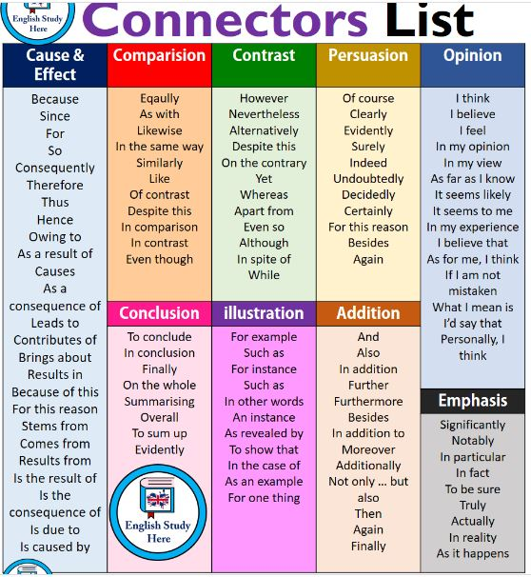

• Based on the development of the guide, fill in your self-evaluation from 1 to 5.
Organization | Puntuality | Comprehension | Use of resources | Honesty | Average

RECURSOS
Libro way to go Grade 7
https://www.theschoolrun.com/what-are-comparatives-and-superlatives https://i.pinimg.com/564x/c0/d1/cb/c0d1cb9047bf7b31036558f062e25e3b.jpg
https://www.anglomaniacy.pl/pdf/grammar-posters-present-continuous.pdf Good luck!

