

GUÍA DE TRABAJO NO PRESENCIAL No.

NOMBRE DEL ESTUDIANTE: |  |  | CURSO:
GRADO: Octavo | CURSO(S): |  | TIEMPO:
ÁREA: Inglés | ASIGNATURA(S): Inglés
DOCENTE: Maria Luisa Mendoza Suarez | No. DE CELULAR:  311 4719264 | CORREO ELECTRÓNICO:  maria.mendoza@itgonzalosuarez.edu.co
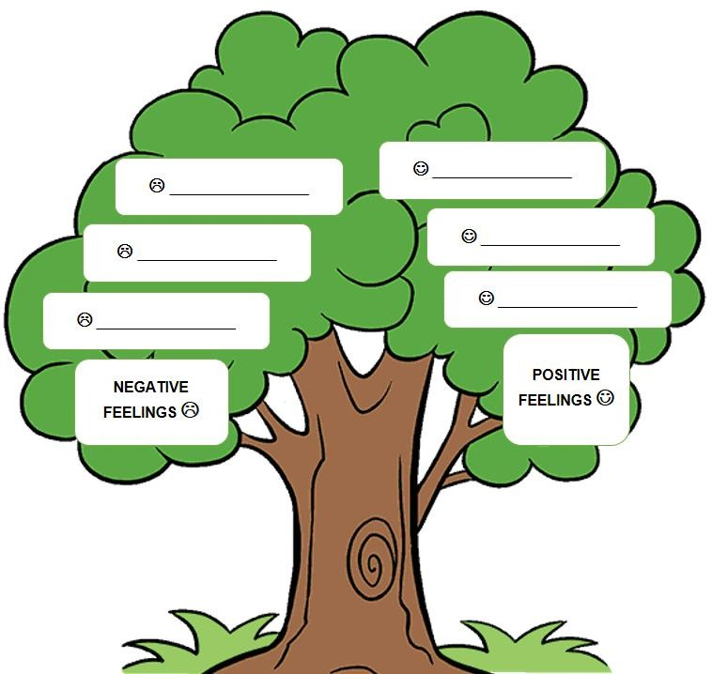
Apreciado estudiante, la presente guía tiene por objeto plantear una serie de actividades que usted debe desarrollar de manera autónoma y responsable en su casa haciendo uso de los recursos de los cuales disponga (internet, bibliografía, cuaderno, entre otros). Se le recuerda que las actividades no exigensu desplazamiento fuera de su hogar y que los medios a través de los cuales puede hacer entregadel desarrollo de la guía son: en físico, al correo electrónico del docente o por medio de WhatsApp.
DESEMPEÑO: Describe emotions and feelings related to body image and self-esteem to express conditions
and to give or ask for suggestions.
TEMA: BODY AND MIND CONNECTION.

ACTIVIDADES DE EXPLORACIÓN
- In the family tree, classify the positive and negative feelings according to the images.

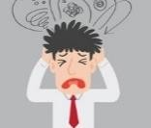
Frustrated Happy


Confident Unhappy

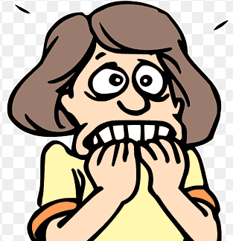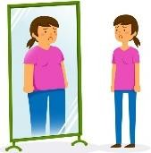
Anxious Self-conscious

- Label the parts of the body with the words from the gift box.

KNEE NECK HEAD WAIST

LEG ARM HAND HIP

SHOULDER FOOT

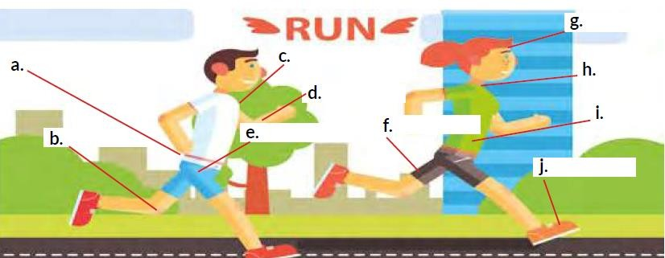
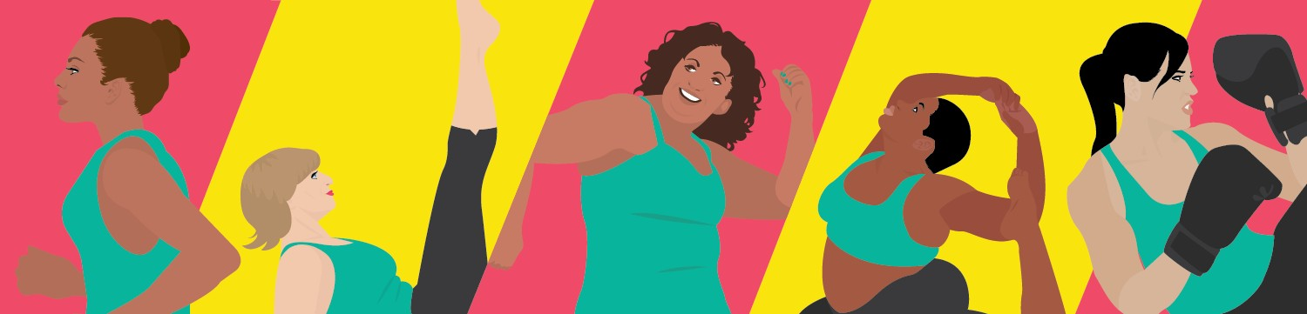





3. Make a drawing of two daily habits that YOU have and that help you feel happy with yourself.
☺ Your habits…
ACTIVIDADES DE ESTRUCTURACIÓN Y PRÁCTICA

Let’s practice vocabulary related to emotions, verbs, parts of the body, and activities we can do to feel better mentally and physically. Also, let’s practice how to express conditions and suggestions!
What is body image? Body image is the picture that we create in our mind of how we look. This perception is not only an idea. It is a feeling that influences our personality. If you have a positive body image, you will feel good about who you are. If you are unhappy with your body image, it will affect your self-esteem and create negative feelings like frustration.
What is self-esteem? Self-esteem is the value that you attribute to yourself. It is important because self- esteem influences your personality and emotions. If you have high self-esteem, you will believe in yourself and be happy and confident. If you have low self-esteem, you can be unhappy, anxious, or extremely self- conscious.
REMEMBER! We use the first conditional to talk about possibilities in the future. We also use it to give suggestions.
☺ WORD BANK!
Look for the meaning of the following words:
*Personality.
*Sleep well.
*Healthy person.
*Self-esteem.
*Confident.
*Self-conscious.
*Frustration.
CAUSE | EFFECT
If you exercise daily,  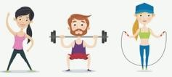 | you will be a healthy person.  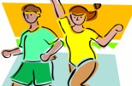
If you sleep well tonight,  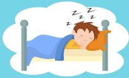 | you will have energy for tomorrow.  




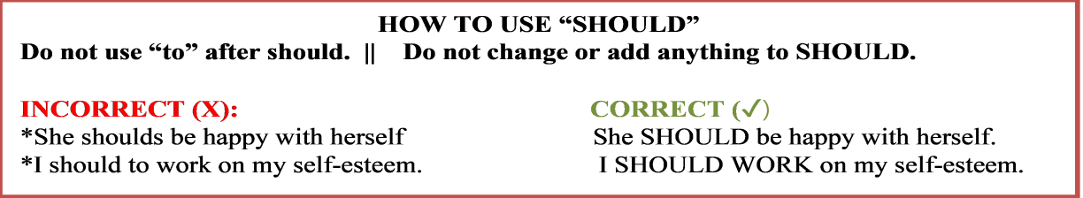
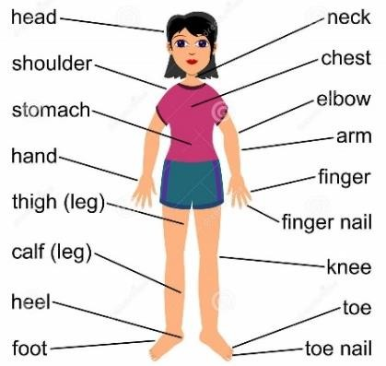
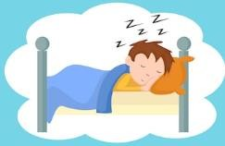
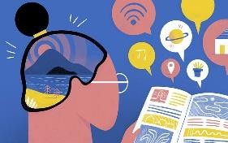
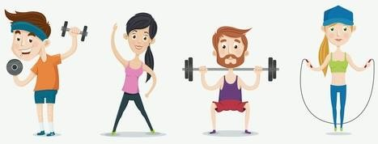
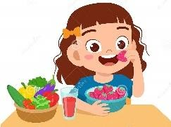

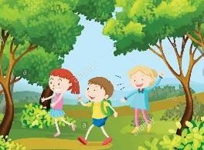
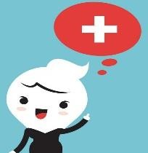
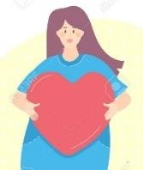
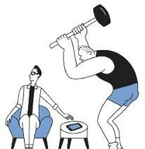
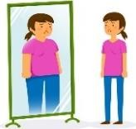
LET’S LEARN!
We have another alternative to give suggestions or advice. We can use the verb SHOULD. Ex: You should express your emotions and feelings.
We should eat healthy.
She should not (shouldn’t) laugh at someone’s appearance.

If we want to ask for someone’s advice or suggestions, we use SHOULD in the interrogative form.
Ex: Should I stand up when my back hurts? Yes, you should.
Should I be an anxious person? No, you shouldn’t. What should I do?

☺ WORD BANK: activities you can do (and suggest) to feel better physically and psychologically. Sleep well Educate yourself Exercise daily Eat healthy

Get relaxed Walk in the nature Think positively Be good to your body Reduce screen time

☺ WORD BANK: Let’s remember the parts of the body:

ACTIVITIES

Use the feelings in the box to complete the following sentences:

Frustrated Happy Confident Self-conscious Anxious
*If you have a positive body image, you will probably be a happy person.
*If you always worry about what you look like, you become .
*If you have high self-esteem, you will be a person.
*If you think you should be perfect in everything, you will get .
*If you have low self-esteem, you will get .

Read the following thoughts and write if the person has a positive or negative body image and high self- esteem or low self-esteem. Justify your answers based on the definition of these concepts.

I think she has and because she

I think she has and
because

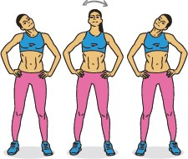
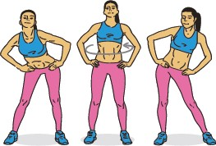
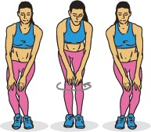
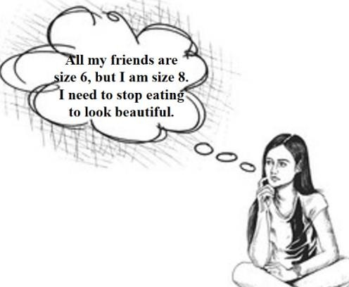
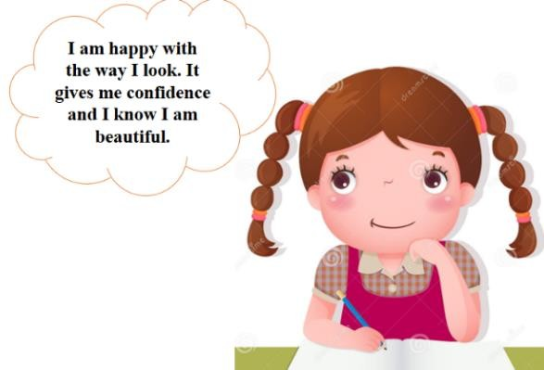
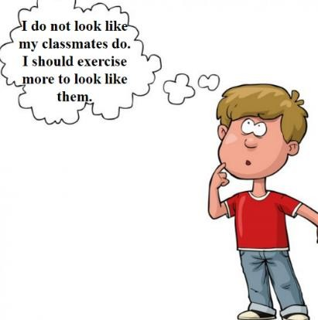

I think he has and because he

- Look at the pictures. Complete the instructions with the parts of the body from the word bank. Then, record a short video in which you practice these routines.

-I am very stressed after my exams. What exercises should I do to relax my
and my shoulders?
-Ok. Stand with your apart and your hands on your
. Then, slowly rotate your to the left, right, and front. Change directions and repeat a couple of times.

-I often get backache. My doctor said I should exercise. What exercises should I do?
-Put your on your hips. Move your to the left and then slowly to the right.

-I want to start running, but I have heard you can get injured. What should I do before starting to run?
-You should warm up your muscles before you run. You should walk for a few minutes. You should do this exercise:
Stand with your together, put your hands on your
and bend them a little. Slowly rotate your knees to the left and to the right.

- Match the following conditions with the corresponding results. Follow the example.

☺ If you eat healthy,
☺ If you have high self- esteem,
☺ If you have a positive body image,
☹ If you believe that there is a perfect body,
you will be frustrated.
you will feel good about who you are, and not only how you look.
you will believe in yourself and you will be confident.
you will show love and respect to your body.

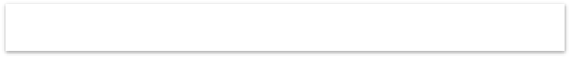

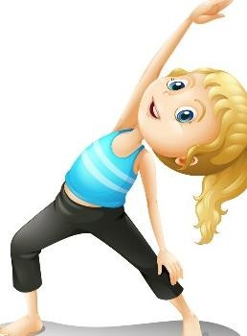


Look at the following sentences and write suggestions using SHOULD and the verbs from the box. Follow the example.
Sleep Exercise Eat Walk Think Be Reduce
Ex: I do not like the way my body looks. Suggestion: You should be good to your body and love it.

  - My eyes hurt because I spend a lot of time on my cellphone. Suggestion: You screen time.
  - I am tired because I fell asleep at 3:00 a.m. Suggestion: You well.
  - My body hurts all the time. Suggestion: You daily.
  - I have a stomachache because I ate a lot of burgers. Suggestion: You healthy.
  - I will fail in my exams. Suggestion: You positively.
  - I am stressed for the noise of the city. Suggestion: You in the nature.

ACTIVIDADES DE TRANSFERENCIA Y VALORACIÓN
    - Read about Juan and his experience with negative body image and low self-esteem. Then, give him five suggestions to solve these problems using SHOULD. Take into account the word bank of activities to feel better.

Hi! My name is Juan and I want to receive your suggestions about some things I feel about myself. I consider I have low self-esteem and a negative body image. To begin with, I am unhappy with my body image. It has generated frustration because it has affected my personality. I have negative feelings and I cannot sleep at night thinking about how others make fun of me for the way I look. I also spend a lot of time on my cellphone to avoid contact with people around me, so I play games on my phone all the time. I am unhappy with who I am and I know I am too self-conscious, but I do not know what to do. I would like to go outside and do other activities. I want to feel happy with who I am and how I look. What should I do?

Your suggestions for Juan:

Carolina wants to exercise more, so she wants to run in the nature. She is worried she will get hurt. Help Carolina by suggesting three exercises to get ready to run. Use the vocabulary related to body parts worked previously and use SHOULD.

Hi! I am Carolina. I want to run. I will read your suggestions to run safely.

.

.

.
- Organize the following words to express conditions and their results. Remember to express the conditions with if and the results with will (first conditional):
Ex: (not sleep well / be tired). If you do not sleep well, you will be tired.
  - (have high self-esteem / be confident):
  - (have low self-esteem / be extremely self-conscious):
  - (exercise daily / be a healthy person):
  - (think positively / be a happy person):
  - (are good to your body / have a positive body image):
- Read the following conditions and results. Then, turn them into suggestions using SHOULD.
Ex: If you sleep well tonight, you will have energy for tomorrow. Suggestion: You should sleep well tonight to have energy for tomorrow.
*If you eat healthy, you will be a healthy person. Suggestion:
*If you have high self-esteem, you will believe in yourself. Suggestion:
*If you reduce screen time, you will sleep better at night. Suggestion:
*If you love yourself, you will be good to your body. Suggestion:
*If you walk in the nature, you will be relaxed. Suggestion:
- Make a poster in which you draw a person with a positive body image and high self-esteem. Also, write SIX sentences for other people to have positive feelings about themselves. Use one folio size paper and take a picture at the result. Look at the example:
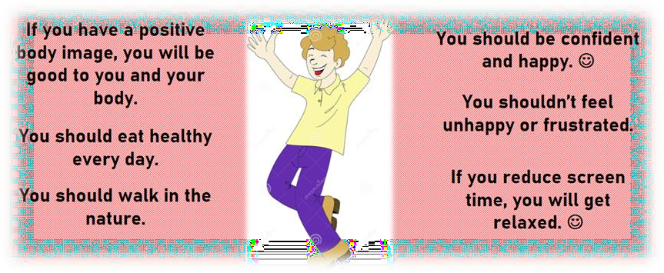
- Based on your work during the development of this guide, fill in your self-evaluation from 1 to 5:
 | Organization | Punctuality | Comprehension | Use of resources | Honesty | Average

RECURSOS
- Book: Way to go! (Eighth grade).
- More information about the first conditional: https://www.youtube.com/watch?v=58GjdEwZgLg
- More information about SHOULD: https://www.youtube.com/watch?v=OxO7YB-lNS0
- More information about positive body image: https://www.youtube.com/watch?v=8GfTtqSAz8s DICTIONARY.


